## What’s the point?

The integral seeks to answer one of the classic calculus problems: the area problem, finding the area between a curve and the x-axis.

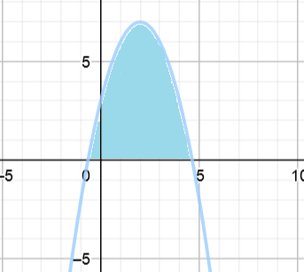

## Indefinite vs Definite Integral

|  |  |
| --- | --- |
| Indefinite Integral | Definite Integral |
| * Family of functions $(+c)$* The antiderivative * Notation: $\int{f\left(x\right)dx}$ | * A number * The area under the curve * Notation: $\int_{a}^{b}{f\left(x\right)dx}$ |

The indefinite integral is the result of undoing the process of deriving a function. Unfortunately, some information about the original function is lost when deriving. Thus, the indefinite integral always results in $f(x)$ + c, because the derivative of c is 0, and therefore could be any number.

Ex: $f\left(x\right)=x^{2}+5, { f}^{'}\left(x\right)=2x, \int{f^{'}\left(x\right)=x^{2}+c}$

All of these ${f\left(x\right)=x}^{2}+c$ functions have the same derivative

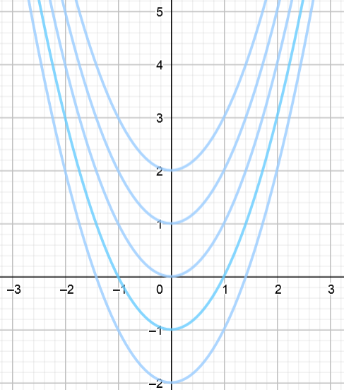

## Fundamental Theorem of Calculus

*If the function $f$ is continuous on the closed interval $[a,b]$ and $F$ is an antiderivative of $f (F^{'}\left(x\right)=f(x))$ on the interval $[a,b]$, then $\int_{a}^{b}{f\left(x\right)dx}=F\left(b\right)-F(a)$*

*Note: this can also be written as $\int_{a}^{b}{f'\left(x\right)dx}=f\left(b\right)-f(a)$*

This allows us to evaluate the definite integral using the indefinite integral

**EXAMPLE 7:**

Kevin analyzed one of his Rubik’s Cube solves by analyzing how many moves he mad made after each second. Selected values from the graph are in the chart below

|  |  |  |  |  |  |  |
| --- | --- | --- | --- | --- | --- | --- |
| x – seconds | 0 | 1 | 3 | 5 | 6 | 7 |
| $f(x)$- turns made | 0 | 9 | 25 | 32 | 40 | 53 |

Find $\int_{a}^{b}{f'\left(x\right)dx}$ including units of measure.

The first fundamental theorem of calculus tells us that

$$\int_{a}^{b}{f'\left(x\right)dx}=f\left(b\right)-f(a)$$

We can then plug in the values we know from $f$

$$\int_{1}^{7}{f^{'\left(x\right)}dx=f\left(7\right)-f\left(1\right)=53 turns-9 turns=44 turns }$$

## The Second Fundamental Theorem of Calculus

If $f$ is continuous on the open interval $I$ containing a, then the area function $A\left(x\right)= \int_{a}^{x}{f\left(x\right)dt}$ is an antiderivative of $f(x)$ on $I$ ($A^{'}\left(x\right)=f(x)$). Thus, $\frac{d}{dx}\int_{a}^{x}{\left[F\left(t\right)dt\right]=f(x)}$

We can then relate combine this with the first derivative

$\int_{a}^{g(x)}{f\left(t\right)dt}=F(g\left(x\right)-F(a)$ so the derivative is

$\frac{d}{dx}\left[F\left(g\left(x\right)\right)-F\left(a\right)\right]$

$=\frac{d}{dx}F\left(g\left(x\right)\right)-\frac{d}{dx}F\left(a\right)$

$=F'(g\left(x\right)g^{'}\left(x\right)-0$

$=f\left(g\left(x\right)\right)g'(x)$

***EXAMPLE 8:***

If $F\left(x\right)= \int_{-5}^{5x+5}{(8t+\sqrt{4t})dt}$, find $F'(4)$

Using the second fundamental theorem we know that $F^{'}\left(x\right)= f\left(g\left(x\right)\right)g'(x)$

$f\left(x\right)=\left(8t+\sqrt{4t}\right) and g\left(x\right)=5x+5$ so

$$F'(x)=\left[8\left(5x+5\right)+\sqrt{4\left(5x+5\right)}\right]\left(5\right)$$

$$F'(4)=\left[8\left(25\right)+\sqrt{4\left(25\right)}\right]\left(5\right)$$

$$F'(4)=[200+10](5)$$

$$F'(4)=1050$$

## Average Value

Definition: If $f$ is integrable on the closed interval $\left[a,b\right],$ then the average value of $f$ on the interval is

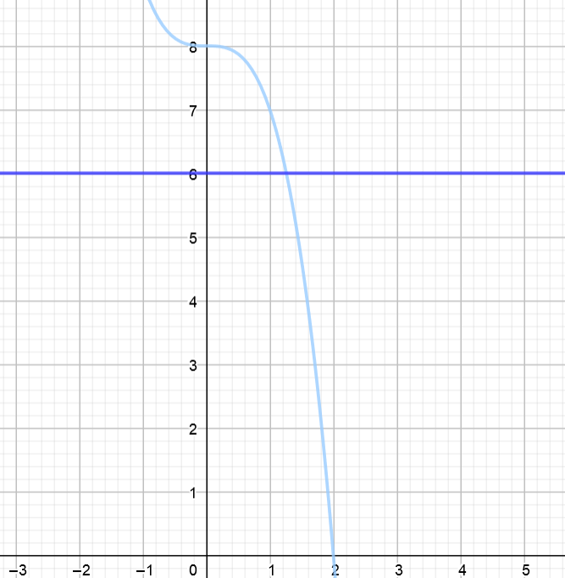How does this work? Dividing the definite integral (area) by the length of the interval results gives you some height. A function with this constant height over the same interval would have the same area.

$$f\left(x\right)= -x^{3}+8, Avg height= f\left(c\right)=\frac{1}{2-0}\int_{0}^{2}{f\left(x\right)dx=6}$$

The average height combined with the interval will result in a rectangle with the same area as the curve.